Ideation Phase
Define the Problem Statements

Team ID | PNT2022TMID31224
Project Name | IoT Based Safety Gadget for Child Safety Monitoring and Notification
Maximum Marks | 2 Marks

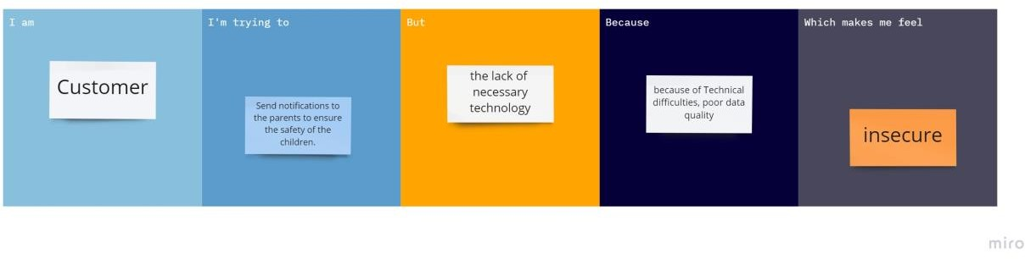

Problem Stateme nt (PS) | I am | I’m trying to | But | Because | Which makes me feel
PS-1 | Customer | Monitor the Child safety and tracking | the lack of necessary technology | because of technical difficulties, poor data quality | insecure
PS-2 | Parent | Provide security to the children | The battery should be recharged regularly | Sometimes we may forget to do | Concerns regarding the child's safety

